Motivators: The Theoretical Motivator

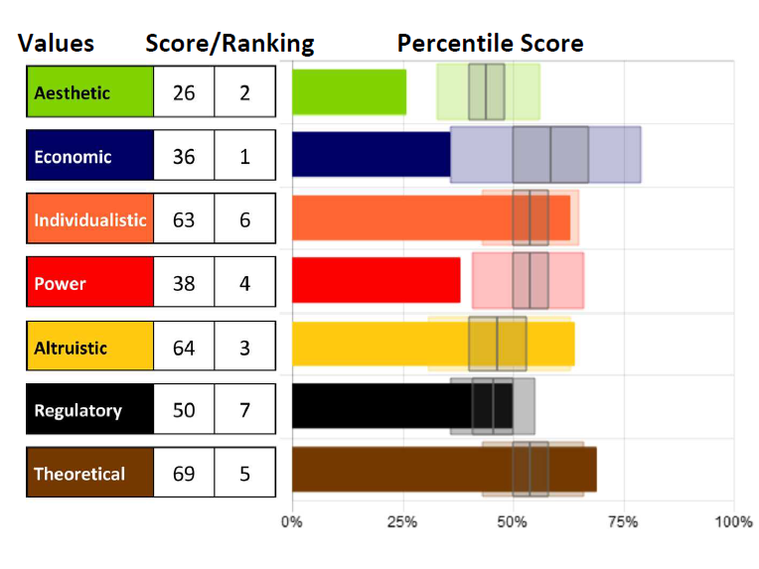
Knowing our specific level of
motivation can be crucial to
helping us understand what
drives our beliefs and actions so
we can bring them into
alignment.

Remember that although we can
explore each motivation
individually, they cannot be
separated. They can only be distinguished; however, all motivators integrate to influence us.

The Theoretical Motivator – the drive for knowledge, learning and
understanding

The desire to uncover, discover and recover the truth, this
motivation needs to gain knowledge for knowledge sake. They
have a need to know. Rational thinking, reasoning, and problem
solving are important to those high in this motivation.
Those who score high in this motivator like complex problems, want
to learn as much as they can to help them be successful, and like
being the expert. They are investigators. Those low in this motivator
only need to know enough to be successful in a particular situation.
They are trial and error learners, situationally learning only what they
need to know, and have very specialized knowledge in areas that are
relevant to their current needs.

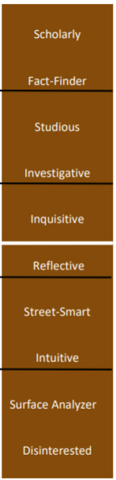
Using this descriptor scale, you can identify a key component to each person’s score in this motivation, as well as see how the scores range from Very Low to Very High, noted by the black lines between each set of descriptors. Each word represents 10 points of 100 on the scale (example: Intuitive people score between 20-29, Studious people score between 70-79 in this dimension).
The white line indicates 50%, perfect balance between high and low in the motivation. Those who score closer to 50% will be situational in applying this motivator. Moving further from that line (high or low) indicates which areas are the more influential.

Whether scores are high or low, the motivators with the furthest distance above or below 50% (above or below “perfect balance” in the center) will be the highest influencers leading to the greatest impact on the decisions being made.

Strengths and Limitations

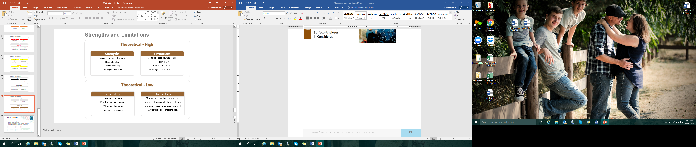

- What drives you in this motivation?
- How can that be helpful and productive for you?
- How can that limit you?

Assessments 24x7 LLC 5927 Balfour Court, Ste. 103 Carlsbad, California 92008 USA (206) 400-6647

